select * from Jobs order by Max_Salary;

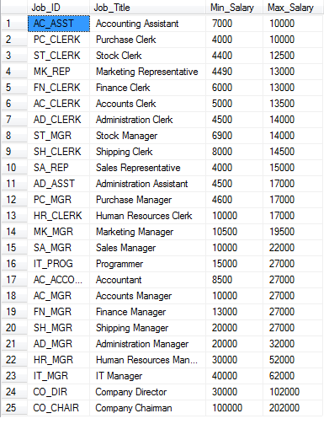

select First_Name, Last_Name, Annual_Salary from Employees

where Hire_Date > 1999/12/31 AND Annual_Salary >= 7000 order by Last_Name desc;

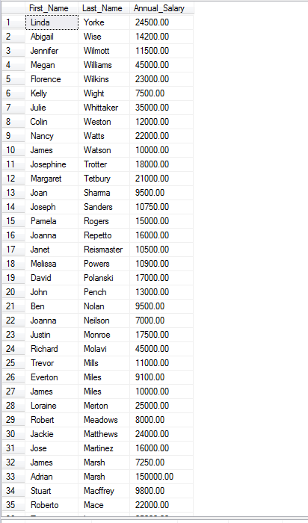

select * from Jobs;

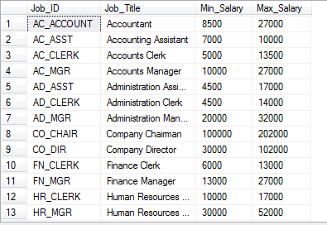

insert into Jobs (Job_ID, Job_Title, Min_Salary, Max_Salary) Values ('AC_ASST', 'Accounting Assistant', 7000, 10000);

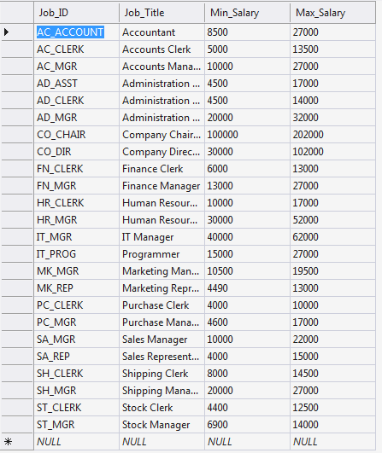

select First_Name, Last_Name, Employee_No from Employees where Job_ID = 'SA_REP' AND Hire_Date >= 15/12/1997 order by Last_Name;

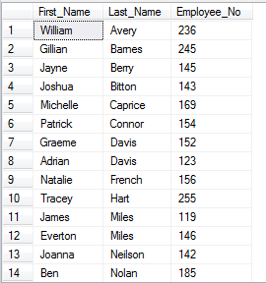

select Last_Name, First_Name, Job_ID from Employees where Commission_Percent > 0.25 order by Last_Name;

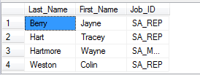

Select Department_No, Last_Name, Annual_Salary from Employees where Hire_Date between '1998/08/26' AND '1999/11/16' order by Last_Name asc;

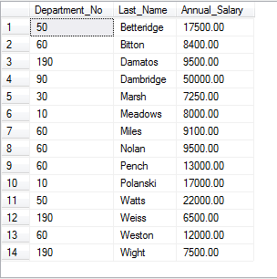

select MIN(Annual_Salary) as thing from Employees;

select AVG(Annual_Salary) as AnotherThing from Employees;

select Avg(Max_Salary) as YetAnotherThing from Jobs;

select MAX(Max_Salary) as YetAnotherThing from Jobs;

